Questions and
answers about the renovations at Ystarvägen 135-141

Why do we need to renovate?
The residence(Bostaden I Umeå) has carried out inspections of the property portfolio, including Ystarvägen 135-149. The lifespan of the surface layers in the bathroom is being reached,
and that water damage has increased at the addresses. It is now time to carry out a bathroom renovation in your area. The bathrooms have a standard from the 80s.

What needs to be fixed in the apartment?
We will renovate your bathroom, and waterproof under the kitchen sink.

When is the renovation expected to start?
We plan to start the renovation as follows:
Ystarvägen 135 February - 25
Ystarvägen 137 March – 25
Ystarvägen 139 April – 25
Ystarvägen 141 April/May

More detailed timetable will be in your stairwell. There will also be other information to read. Get into the habit of reading the information every day.

Is the bathroom being completely renovated?
Yes. This means, among other things, that we change the surface layer (floor and walls) in the bathrooms. The new surface layers will consist of wet room carpet and painted fabric. We are changing the floor drains and adapting them to a shower area. The elements in the ceiling angle are removed and we install a heated towel rail. Bathroom cabinets including lighting and electrical outlets are installed.
Porcelain (toilet seat, sink, faucet) that is older than five years is replaced.

(If your bathroom has recently been renovated due to water damage, it is not affected by this renovation, then only waterproofing of the kitchen will be relevant for you)’
If your bathroom has been renovated within the last 7-8 years, we will make an assessment to see if we can keep the surface layer. If it is, we just change the electricity and reline the pipe trunks.

How long does the work in the bathroom take?
Normally, the work takes between 4-5 weeks per bathroom. If there are elevated humidity values ​​in the bathroom, they may take longer.

Water shut-offs
•While the renovation is taking place in your apartment, there is a possibility to shower at Tenton Gym. Access cards can be picked up from the contractor PEAB at their office.
• We set up two shower/WC barracks on the farm.
• Toilet will work with flushing on evenings and weekends.
• Times when the toilet cannot be used, there is a replacement toilet according to point above and in the laundry rooms.
The kitchen will have the water on as usual except during temporary shutdowns during the day. A closure schedule with approximate daytime times will be distributed.

Are new fixtures installed in the apartment?
Yes, the bathrooms.

What is being done in the kitchen?
We waterproof under the sink. This is to minimize possible damage in case of water leaks.
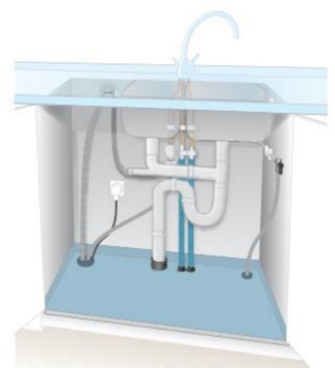

Can you make some color choices in the bathroom?
Yes, there will be 3 options for floor mats and wall mats that you tenants can choose from. If you don't want to choose, choose Bostaden.
The color choices will be in your stairwell on the mezzanine level.

Can I keep my bathtub?
Those of you who have a bathtub will get to choose whether you want a shower or have your bathtub reassembled.

Can you live in the apartment in the meantime?
Yes!

Living on the ground floor?
• The apartments on the ground floors are not affected by the renovation in their bathrooms but are affected by the car noises in the house.

What will these renovation measures mean for you as a tenant?
Working hours in your apartment on weekdays between 07.00-17.00
• Construction and drilling works
• Impact sound
• Engine noise from cars
• It is a construction site

What should I remove before the renovation?
All your own things in the bathroom must be taken out of the bathroom and it must be ready by 07.00 from the day the work starts at your home.

Also remove your things such as shelves, paintings and things that are on the floor in the bedroom/living room at least 1 meter from walls facing the bathroom.
In the hall, the toilet seat will be temporarily set up during the day when the work is in progress. The hall must be kept free of things (even on walls, if possible).
Keep the outside of the apartment door clear of things so that it will be easier to get in and out with building materials.

Affected the laundries?
Yes, they will be renovated during the course of the project. You will always have access to a laundry room on the nearest floor.

Master key
PEAB and their subcontractors will use the master key during the renovation period. If anyone has a problem with that, you can contact Bostaden.

Inspection of the bathroom
Inspection of the bathroom takes place approximately 2 month after the renovation is completed.

Rent reduction!
You will receive a reduction for the disturbances in connection with the renovation. It is paid out approximately 3 months after the renovation has been inspected and completed.

The traffic situation in the courtyard, how is it affected?
More traffic inside the yard.
Containers, sheds and fences will be seen in various places in the area.

What rent increase will there be?
The renovation will mean a rent increase of between SEK 70 and SEK 145.

The re Miscellaneous
- It will be noisy in the area during the renovation
- The contractor will have containers on site, it is strictly forbidden to throw rubbish in their containers. nt increase is negotiated with the tenant association
- If you have pets, notify Peab when you receive a notification about when they will start in your apartment. You can also contact the residence.
- When the renovation in your bathroom is complete, the information sheet is removed and you can use your bathroom.

You can read more about the renovation at:
https://www.bostaden.umea.se/artikel/ystarvagen-135-149

